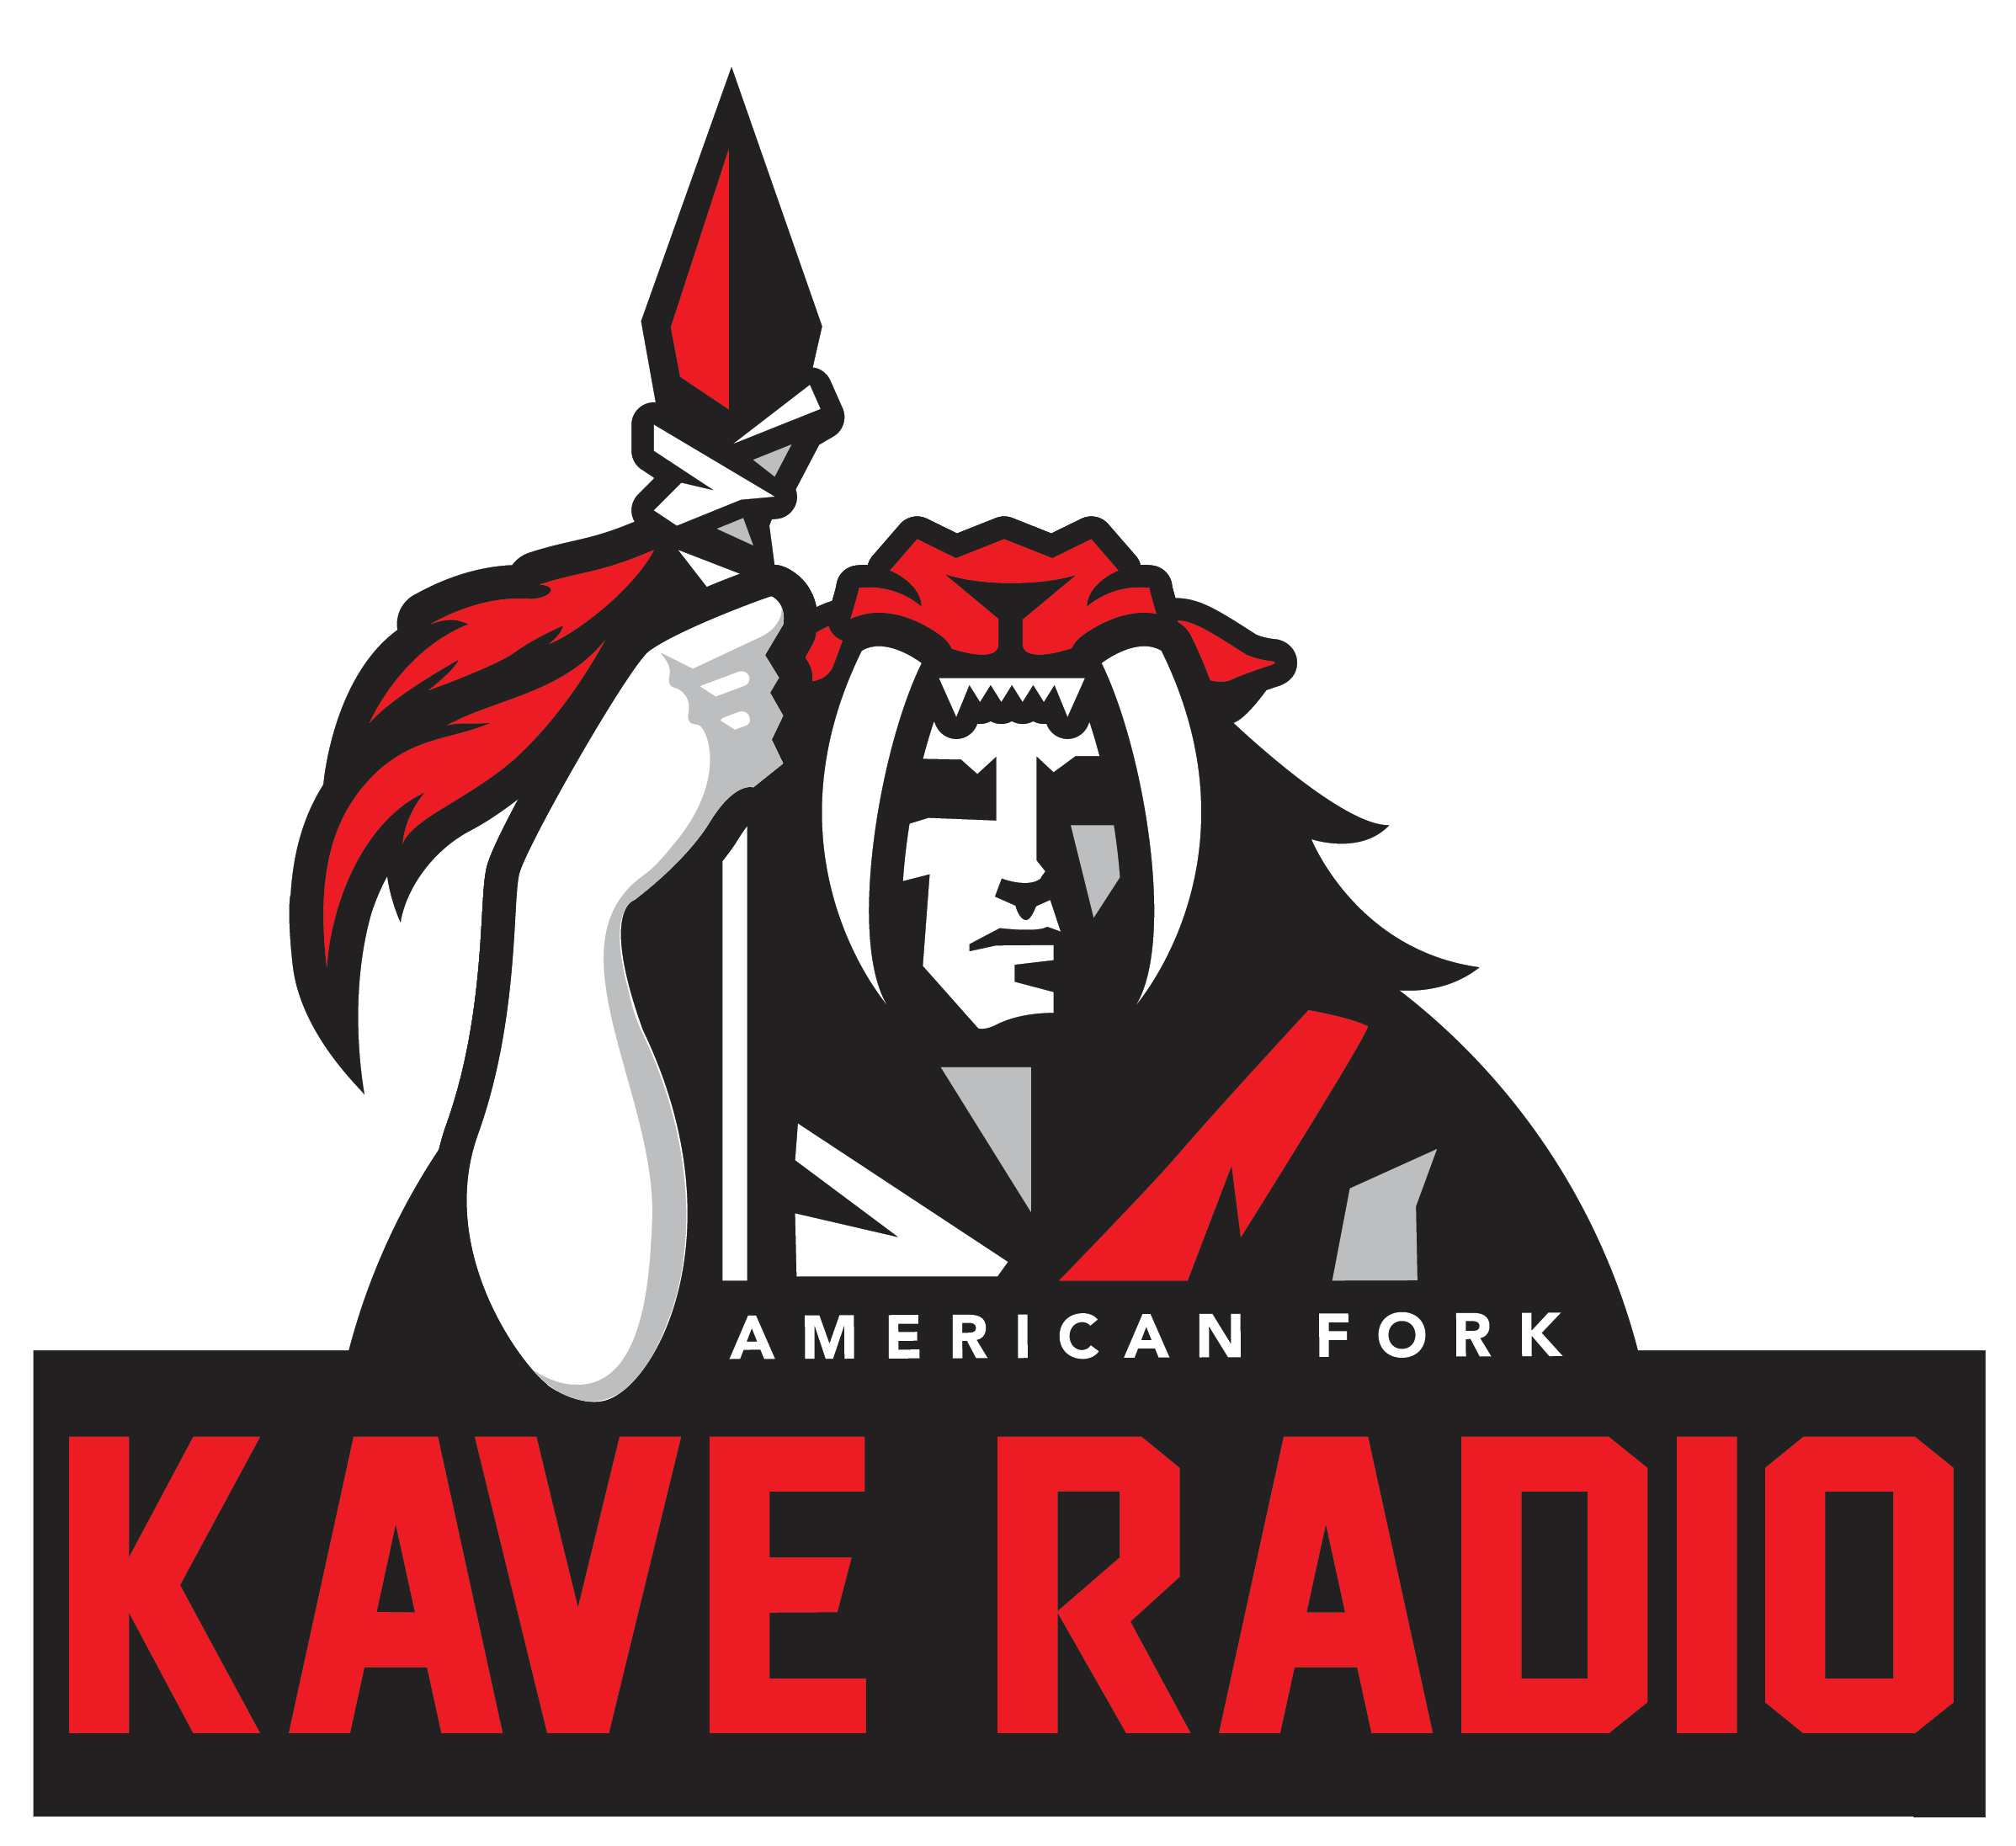

Radio Broadcast 1 (KAVE Radio)
Course Disclosure
AFHS Fall 2013

Course Instructor: Zac Durrant
Contact Information: zdurrant@alpinedistrict.org
Class Website: www.kave-tv.weebly.com

Course Description:
This course is designed to provide students with the basic knowledge and skills related to the radio broadcast industry. Includes instruction and hands-on assignments in the following areas: pre-production, live production, vocal skills, equipment, and radio rules and regulations.

Classroom Rules & Etiquette: It is assumed that students come to this class with a basic understanding of classroom appropriate behaviors which include, being on time, raising your hand, respecting others when they are speaking (knowing when to listen) and doing all assignments. Extra credit points are given to students who make a sincere effort to learn.

- NO cellphone use in class. If they are seen, you will lose points on current assignment.
- NO backpacks around the computers. Keep backpacks at the side of the class.
- NO food or drink in the lab or in the studio.

Internet Usage: 1. Using the Internet means that you have read the Internet Usage policy and both you and your parents have agreed by signing the fair use policy which will be on digital file with the school. 2. Video/Images/Audio taken and submitted to the instructor during the course of the class may be subject to online usage (ie: AFHS official website, or our class website) for either educational purposes or to promote your work. If you misuse the internet in any way, I reserve the right to take away that privilege in my classroom.

Your Grade: Daily punctuality is worth 10 points & daily participation is also worth 10 points. Quizzes are worth 100 points and will be given three times a term. The semester final is worth 500 points. Video assignments will be given throughout the year. Extra credit is available on a case-by-case basis.

A = 100%-90% B = 89%-80% C = 79%-70% D = 69%-60% F = 59%-0%

Late Work: Deadlines are crucial. In the industry if you don’t complete your package on time it doesn’t show and you are fired. If you fail to complete your assignments by your deadline* -- you will get a 0. Alpine School District has committed thousands of dollars to your progression in becoming a literate, critical thinking individual with employable skills. *Plenty of class time will be given for you to complete your assignment.

Recording Content: You have the opportunity to be the “face” of the school in a broadcast sense. You will not take this for granted. EVERY student is expected to be professional. Part of what we will be doing in class will be live broadcast, students that are on-air will be expected to be professional, one inappropriate comment and you will lose your on-air status, along with points lost on current assignment.

School Equipment Use: KAVE TV has a few pieces of equipment that is available for this radio class. Audio equipment may be checked out. When these items are entrusted to students, the utmost care must be used. This equipment is not cheap. I will only check out higher end equipment to those who know how to use them. Damage to equipment is the sole responsibility of the student. The student/parents will be expected to pay for any damages or replacement of equipment. Disrespect or careless handling of equipment will result in loss of student opportunity to use school equipment. You may bring equipment from home; the school/instructor is not responsible for anything that happens to it.

Equipment Checkout: Equipment will be checked out through the instructor. Each piece of equipment will have a check out period of 48 hours. For example, if you check out a camera on Monday during A1, it is due on Wednesday A1. Friday’s due date is Monday. Late fees apply for equipment that is not turned in on time. Equipment will be checked out on a first come first serve basis, unless approved by instructor.

Radio Broadcast 1 2013-14

Print Student’s Name:

Disclosure Acceptance
I have read and agree to follow the above plan and realize that this is an elective course. I understand that will use school equipment and that I am responsible for that equipment like it is my own.

____________________________________________ ___________
Student Date

____________________________________________ ___________
Parent Date

--------------------------------------------------------------------------------------------------------------

Equipment Checkout Permission Form
I give permission for my child to check out school equipment. I understand that it is my responsibility to make sure the equipment is returned in a timely manner and in the same condition in which it is checked out. I understand that I am responsible to pay for any damage that is caused while we have the equipment.
____________________________________________ ______________
Student Date
____________________________________________ ______________
Parent/Guardian Date

